What we are learning in Reception Term 5 Our theme this term is ‘In the Garden’
Reminders | Our PE day is Thursday. Please send your child into school wearing PE kit every Thursday. Please ensure all belongings are named. Children should only have water in their bottles.
Reading Café:  Dates: | Note time is now 14:50pm – 15:10pm after feedback from parents/carers. Thank you!  19.4.24, 3.5.24, 17.5.24
Phonics | We will continue to learn phase 4 Phonics and revise what we have previously learnt in Phase 2 and Phase 3.
Maths | Each week we will focus on a different unit of work. We currently use White Rose Maths to plan and teach our lessons. We will be covering numbers to 20 (counting to and above verbally) and we will be beginning to add and take away. We can now count to 10, use number bonds and find doubles to 10!
Communication and Language | New vocabulary to be introduced - plant, leaf, grow, sunlight, stem, petal, ground, earth, shoot, root, pollination, seed, nutrients, fertilise, minibeast, insect, wormery, life cycle, chrysalis, cocoon
Personal, Social and Emotional Development | Our Jigsaw piece this term is ‘Relationships’. We will learn about our families and some of the jobs that I do, how to make friends, how it feels to be a friend and make a friend, what to do if I feel lonely, how to solve problems and stay friends, the impact of unkind words, how to use Calm Me time to manage my feelings and how to be a good friend.
Physical Development | This term we will be developing our dance skills. We will also begin to practice for Sports Day! Updates to follow on specific dates and times.
Understanding the World | In this topic, children will explore the theme of ‘In the Garden’ by learning about plants and how they grow and what they need to grow, then moving on to learning all about the wonderful creatures we come across outside too.  We will be exploring the life cycles of butterflies and frogs, as well as planting our very own herbs, and beans.
Expressive Arts and Design | The artist of the term is Georgia O’Keefe. She was known for her paintings of enlarged flowers, and we will be  exploring flowers and plants in close detail. We will be making art based on the beautiful flowers and plants we see in the natural world around us.
Ways in which you can support your child’s learning at home this term:
Reading a minimum of 3 times a week. Practice recalling number bonds to 10. Practice reading phase 4 common exception words by sight.

Phase 4 Common Exception Words we are revising:
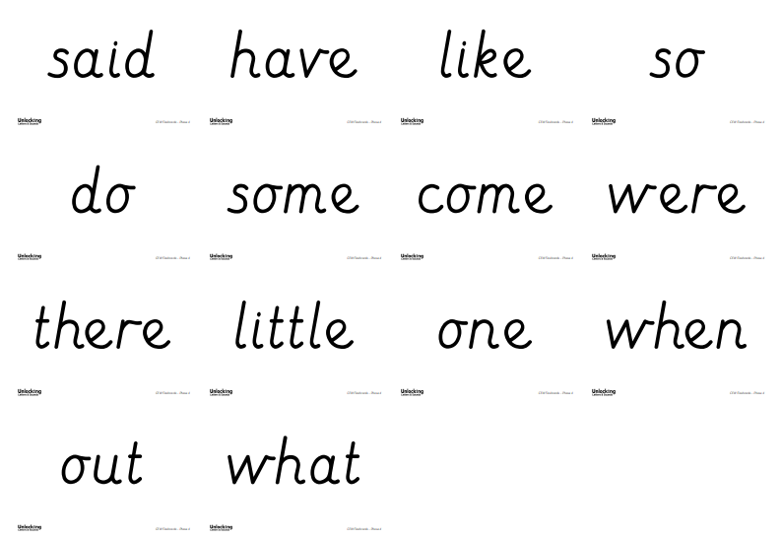
Number Bonds to 10 we are learning to remember:
